- UK mortgage demand is in decent shape, with approvals at their highest level since last winter when the impending stamp duty deadline had boosted activity. House price growth has also firmed of late. Less stretched mortgage affordability is part of the story, and mortgage rates should drop further in the near-term in response to the recent fall in swap rates.
- But even if the Monetary Policy Committee offers validation of markets' recent dovish shift at next week's meeting, we think the scope for further falls in swap rates and mortgage rates is limited. With pay growth continuing to slow, further improvements in mortgage affordability will be limited and the recent pickup in mortgage demand should begin to tail off in early-2026.
In H1 2025, analysing the state of the housing market was made difficult by the distortions caused by March's end to the temporary increase in stamp duty thresholds. But that volatility is now well behind us, and mortgage demand appears to have emerged in a decent state. This week's Money & Credit release for September reported the highest level of mortgage approvals since December 2024, a period when demand was being boosted by the impending stamp duty deadline (Chart 1). September's outturn was a clear step up on the levels seen in H1 2024, before the distortions began to appear. It's a similar story with prices, with Nationwide reporting a second successive month of solid price growth in October.
Improved mortgage affordability is a key part of the story. Our new home buyer affordability index, which is based on the affordability of mortgage payments, suggests that house prices are currently overvalued by around 6%. This is a big improvement on this time last year (11% overvalued) and in mid-2023, when prices were 27% overvalued. This reflects a combination of a steady decline in quoted fixed-term mortgage interest rates, strong pay growth, and subdued growth in house prices.
In the near-term, there's a good chance that mortgage affordability will improve further. As we reported in last week's edition, markets reacted strongly to September's inflation data. Two- and five-year swap rates are currently around 25bps lower than they were at the end of last month, and this should mean that quoted mortgage rates become cheaper over the next few weeks.
Chart 1: Mortgage demand is well up on H1 2024 levels, supported by lower interest rates
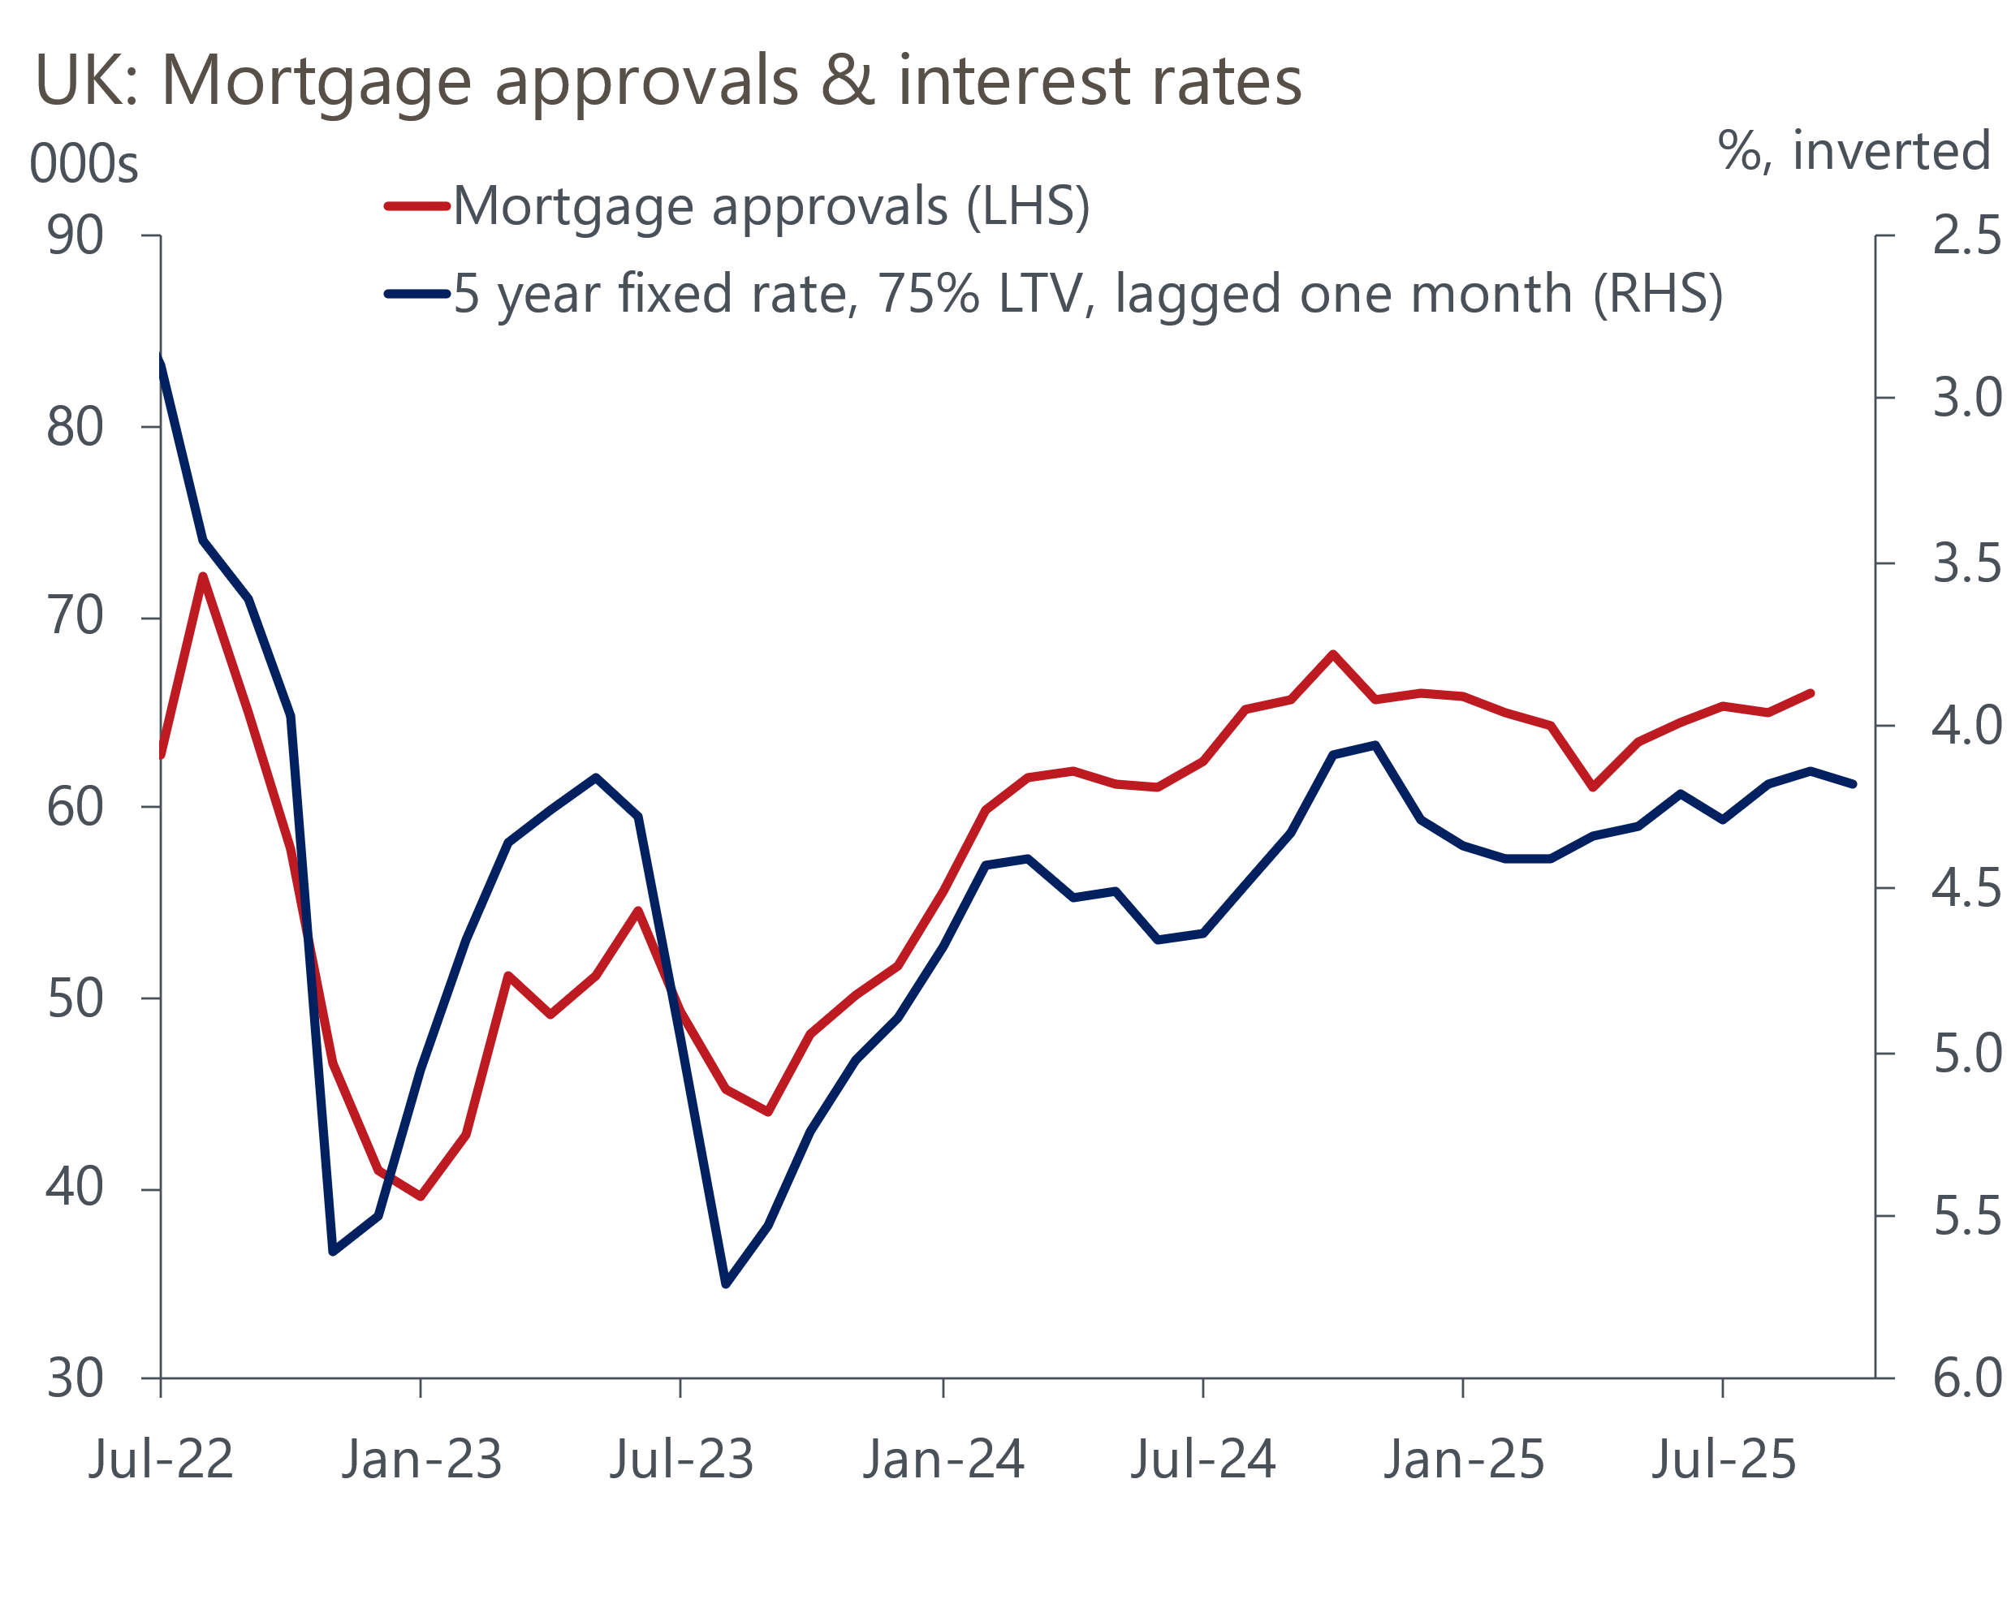
Source: Haver Analytics

Whether the dovish repricing holds will be heavily influenced by next week's Monetary Policy Committee meeting. Markets still think the probability of a November rate cut is relatively low, at around 25%, and we also think it's very unlikely that the MPC will move next week. But market pricing now implies that the chances of a cut by the December meeting are as high as 60% (Chart 2).
Chart 2: Markets now expect the MPC to cut again in December
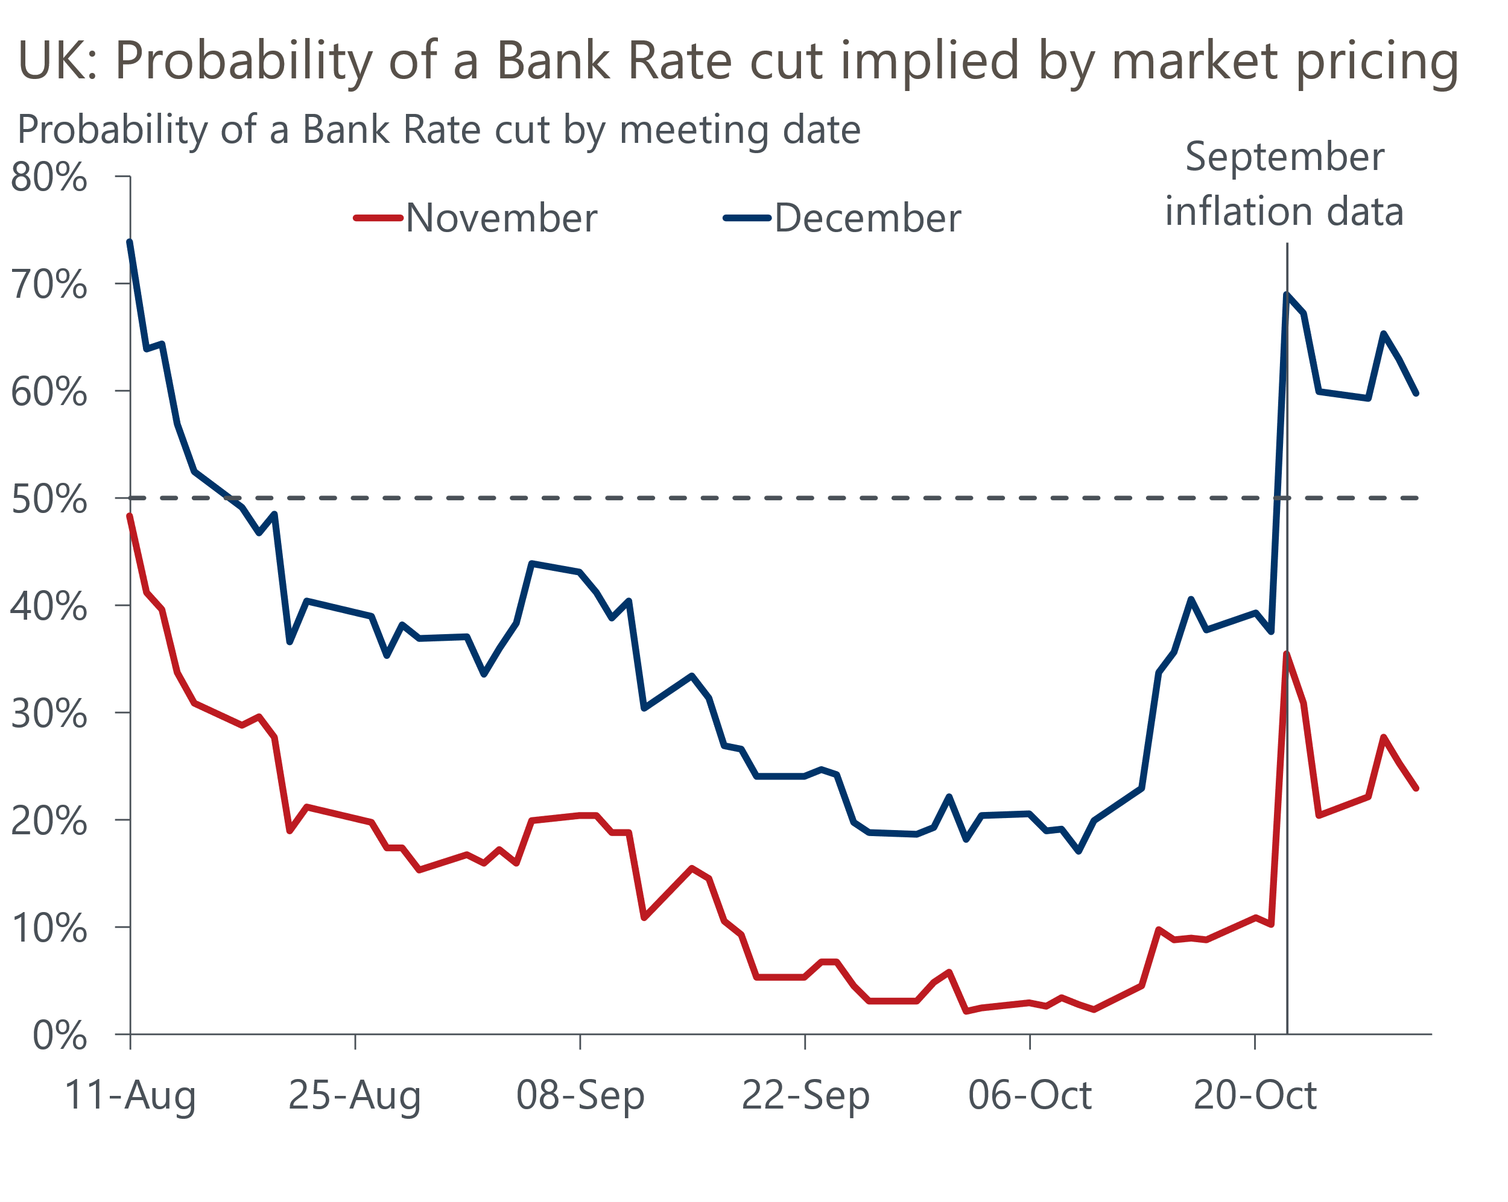
Source: Oxford Economics calculations using data from Haver Analytics
The expectation that the Budget will tighten fiscal policy is a large part of that story. But given that the repricing was so heavily linked to the inflation release, the committee's views on whether September's data has really shifted the dial on the inflation outlook will be key to where market pricing goes from here.
One potentially positive development of next week's meeting is that we should get a much better idea of where each individual MPC member stands. As part of its programme to improve communications, the BoE will introduce a series of changes to its outputs, with the minutes including individual statements from each committee member. Though stopping short of the 'dot plots' published by the US Federal Reserve, this should give us a much clearer idea of how the views of committee members are evolving and promises to be a big improvement on the current situation where we've had to wait for members to give a speech or appear before the Treasury Select Committee to identify any change of view. For some members, the wait for such commentary has often been frustratingly long.
It now looks like inflation won't hit the 4% mark that BoE research found could trigger higher inflation expectations, while September's release provided some tentative evidence that cooling pay growth might finally be passing through into inflation. But it was only one month's data, and we think most of the committee will continue to adopt a cautious approach until they've seen more evidence that core inflationary pressures are indeed easing and that pay growth will slow to a target-consistent pace next year.
But even if the MPC does offer some validation of markets' recent dovish shift, we think the scope for further falls in swap rates and, therefore, mortgage rates, is quite limited. Current market pricing implies that Bank Rate will be back within the range that most MPC members appear to consider to be neutral by the middle of next year. And though we think that rates could ultimately fall a bit further, it will likely take some time for the majority of the committee to come round to that way of thinking in an environment of sticky inflation.
So any further improvements in mortgage affordability are likely to be modest, particularly if pay growth continues to slow. This suggests we're likely to see the recent improvement in mortgage demand begin to tail off in the early part of next year, with the housing market struggling to regain momentum until the valuation gap has receded further.

The week ahead
The November Monetary Policy Committee meeting is the highlight of next week's calendar. We expect the MPC to keep Bank Rate on hold at 4%, breaking the cut-hold pattern it has employed since the start of the rate-cutting cycle last summer. Though the recent downside surprise for inflation may have provided some reassurance, we think most committee members will want to see evidence of sustained downside surprises in the data and that pay growth will slow to a target-consistent pace next year before voting to cut again.
October's flash S&P Global survey reported a modest improvement in the composite PMI, though a balance of 51.1 was still some way below the results of early summer. We suspect that corporate sentiment has been hit by rumours of tax rises in the upcoming Budget and October's final results are likely to come in close to the flash figures.
Table 1: Week ahead calendar
Date | Events | Period | Measure | Unit | Previous | Forecast
Nov 3 | S&P Global manufacturing | Oct | PMI | % bal | 49.6 | 49.6
Nov 5 | S&P Global services | Oct | PMI | % bal | 51.1 | 51.1
Nov 5 | S&P Global composite | Oct | PMI | % bal | 51.1 | 51.1
Nov 6 | S&P Global construction | Oct | PMI | % bal | 46.2 | 47.0
Nov 6 | BoE Bank Rate decision | Nov | Bank Rate | % | 4.00 | 4.00
Source: Oxford Economics

Key forecasts
Table 2: UK forecast overview
(Annual percentage changes unless specified)
 | 2023 | 2024 | 2025 | 2026 | 2027 | 2028
GDP | 0.3 | 1.1 | 1.5 | 0.9 | 1.3 | 1.7
Private consumption | -0.3 | -0.2 | 1.0 | 1.1 | 1.1 | 1.7
Fixed investment | 0.5 | 1.8 | 2.1 | 0.5 | 1.5 | 2.0
Government consumption | 2.1 | 3.4 | 2.1 | 1.7 | 1.6 | 1.7
Exports of goods and services | -2.3 | 0.6 | 3.0 | 0.2 | 1.2 | 1.5
Imports of goods and services | -1.6 | 2.6 | 3.9 | -0.5 | 1.2 | 1.5
Industrial production | -2.6 | -1.6 | -0.3 | -0.1 | 1.1 | 1.4
Consumer prices | 7.3 | 2.5 | 3.5 | 2.8 | 2.5 | 2.2
Unemployment rate (%) | 4.1 | 4.3 | 4.7 | 4.9 | 4.8 | 4.4
Current a/c balance (% of GDP) | -3.6 | -2.2 | -3.1 | -2.6 | -2.4 | -2.3
Government balance (% of GDP) | 5.2 | 5.1 | 4.6 | 3.7 | 3.1 | 2.7
Central bank policy rate (%, EOP) | 5.25 | 4.75 | 4.00 | 3.50 | 3.00 | 2.75
10yr govt. bond yield (%, EOP) | 3.54 | 4.57 | 4.70 | 4.28 | 3.80 | 3.51
Exchange rate (US$ per £, EOP) | 1.27 | 1.25 | 1.34 | 1.34 | 1.34 | 1.34
Exchange rate (euro per £, EOP) | 1.15 | 1.21 | 1.15 | 1.15 | 1.15 | 1.15
Source: Oxford Economics
Table 3: Quarterly forecasts for the UK
 | 2025 |  |  |  | 2026
 | Q1 | Q2 | Q3 | Q4 | Q1 | Q2 | Q3 | Q4
GDP (% year) | 1.7 | 1.4 | 1.4 | 1.3 | 0.9 | 0.9 | 0.9 | 1.0
CPI inflation (% year) | 2.8 | 3.5 | 3.9 | 3.7 | 3.4 | 2.6 | 2.6 | 2.6
Bank Rate (%, EOP) | 4.50 | 4.25 | 4.00 | 4.00 | 3.75 | 3.75 | 3.50 | 3.50
10yr gilt yield (%, EOP) | 4.70 | 4.48 | 4.70 | 4.70 | 4.69 | 4.58 | 4.44 | 4.28
US$ per £ (EOP) | 1.29 | 1.37 | 1.35 | 1.34 | 1.34 | 1.34 | 1.34 | 1.34
Euro per £ (EOP) | 1.20 | 1.17 | 1.15 | 1.15 | 1.15 | 1.15 | 1.15 | 1.15
Source: Oxford Economics

Latest Country Economic Forecast:
October 13, 2025

Recent publications

Data Insights
Mortgage activity has stabilised after distortions earlier this year
PMI points to soft pre-Budget growth
Retail sales surged again in September
Inflation surprised to the downside in September
Public finances remain fragile in the run up to the Budget

Research Briefings
MPC preview – softer data unlikely to herald November cut
What should the Chancellor do in the Budget?
What happens if markets lose faith in the fiscal approach?
What will the Chancellor do in the Budget?
Fiscal fragility could reveal sterling's vulnerability

Contacts

Oxford Economics' UK team
- Andrew Goodwin - Chief UK Economist - agoodwin@oxfordeconomics.com
- Edward Allenby - Senior UK Economist - eallenby@oxfordeconomics.com

